**Loginsign.java**

|  |
| --- |
| package tour; |
|  |

|  |
| --- |
|  |
|  |

|  |
| --- |
| import java.awt.event.ActionEvent; |
|  |

|  |
| --- |
| import java.awt.event.ActionListener; |
|  |

|  |
| --- |
|  |
|  |

|  |
| --- |
| import javax.swing.*; |
|  |

|  |
| --- |
|  |
|  |

|  |
| --- |
| import com.codoid.products.exception.FilloException; |
|  |

|  |
| --- |
| import com.codoid.products.fillo.Connection; |
|  |

|  |
| --- |
| import com.codoid.products.fillo.Fillo; |
|  |

|  |
| --- |
| import com.codoid.products.fillo.Recordset; |
|  |

|  |
| --- |
| public class Loginsign { |
|  |

|  |
| --- |
| JFrame f; |
|  |

|  |
| --- |
| Loginsign() { |
|  |

|  |
| --- |
| JFrame frame = new JFrame("Login Form"); |
|  |

|  |
| --- |
| JLabel l1 = new JLabel("Login Form"); |
|  |

|  |
| --- |
|  |
|  |

|  |
| --- |
| JLabel l2 = new JLabel("Username"); |
|  |

|  |
| --- |
| JLabel l3 = new JLabel("Password"); |
|  |

|  |
| --- |
| JTextField tf1 = new JTextField(); |
|  |

|  |
| --- |
| JPasswordField p1 = new JPasswordField(); |
|  |

|  |
| --- |
| JButton btn1 = new JButton("Login"); |
|  |

|  |
| --- |
| JButton sign =new JButton("SignUp"); |
|  |

|  |
| --- |
| l1.setBounds(100, 30, 400, 30); |
|  |

|  |
| --- |
| l2.setBounds(80, 70, 200, 30); |
|  |

|  |
| --- |
| l3.setBounds(80, 110, 200, 30); |
|  |

|  |
| --- |
| tf1.setBounds(300, 70, 200, 30); |
|  |

|  |
| --- |
| p1.setBounds(300, 110, 200, 30); |
|  |

|  |
| --- |
| btn1.setBounds(400, 160, 100, 30); |
|  |

|  |
| --- |
| sign.setBounds(250, 160, 100, 30); |
|  |

|  |
| --- |
| frame.add(l1); |
|  |

|  |
| --- |
| frame.add(l2); |
|  |

|  |
| --- |
| frame.add(tf1); |
|  |

|  |
| --- |
| frame.add(l3); |
|  |

|  |
| --- |
| frame.add(p1); |
|  |

|  |
| --- |
| frame.add(btn1); |
|  |

|  |
| --- |
| frame.add(sign); |
|  |

|  |
| --- |
|  |
|  |

|  |
| --- |
| frame.setSize(800, 400); |
|  |

|  |
| --- |
| frame.setLayout(null); |
|  |

|  |
| --- |
| frame.setVisible(true); |
|  |

|  |
| --- |
|  |
|  |

|  |
| --- |
| btn1.addActionListener(new ActionListener(){ |
|  |

|  |
| --- |
| public void actionPerformed(ActionEvent e){ |
|  |

|  |
| --- |
| String un=tf1.getText(); |
|  |

|  |
| --- |
| String pwd=p1.getText(); |
|  |

|  |
| --- |
| int stats=0; |
|  |

|  |
| --- |
| Fillo filloc= new Fillo(); |
|  |

|  |
| --- |
| Connection connection1; |
|  |

|  |
| --- |
| try { |
|  |

|  |
| --- |
| connection1 = filloc.getConnection("tour.xlsx"); |
|  |

|  |
| --- |
| String str1Queryc ="SELECT * FROM Sheet1 WHERE EXISTS (SELECT Username FROM Sheet1 WHERE Username='"+btn1.getText()+"')"; |
|  |

|  |
| --- |
|  |
|  |

|  |
| --- |
|  |
|  |

|  |
| --- |
| Recordset rsc=connection1.executeQuery(str1Queryc); |
|  |

|  |
| --- |
| if(un.equals("") ||pwd.equals("")) { |
|  |

|  |
| --- |
|  |
|  |

|  |
| --- |
| JOptionPane.showMessageDialog(null,"Kindly Enter both your Username and Password"); |
|  |

|  |
| --- |
| }else { |
|  |

|  |
| --- |
| while(rsc.next()) { |
|  |

|  |
| --- |
| if(rsc.getField("Password").equals(pwd)) { |
|  |

|  |
| --- |
| JOptionPane.showMessageDialog(null,"Login Successful!!!"); |
|  |

|  |
| --- |
| frame.dispose(); |
|  |

|  |
| --- |
| new city(); |
|  |

|  |
| --- |
| stats=stats+1; |
|  |

|  |
| --- |
| break; |
|  |

|  |
| --- |
| } |
|  |

|  |
| --- |
|  |
|  |

|  |
| --- |
| } |
|  |

|  |
| --- |
| if(stats==0){ |
|  |

|  |
| --- |
| JOptionPane.showMessageDialog(null,"Incorrect Username or Password"); |
|  |

|  |
| --- |
|  |
|  |

|  |
| --- |
| } |
|  |

|  |
| --- |
| } |
|  |

|  |
| --- |
|  |
|  |

|  |
| --- |
| } catch (FilloException e1) { |
|  |

|  |
| --- |
|  |
|  |

|  |
| --- |
| e1.printStackTrace(); |
|  |

|  |
| --- |
| } |
|  |

|  |
| --- |
|  |
|  |

|  |
| --- |
|  |
|  |

|  |
| --- |
| } |
|  |

|  |
| --- |
| }); |
|  |

|  |
| --- |
|  |
|  |

|  |
| --- |
| sign.addActionListener(new ActionListener(){ |
|  |

|  |
| --- |
| public void actionPerformed(ActionEvent e){ |
|  |

|  |
| --- |
| frame.dispose(); |
|  |

|  |
| --- |
| new signup(); |
|  |

|  |
| --- |
| } |
|  |

|  |
| --- |
| }); |
|  |

|  |
| --- |
|  |
|  |

|  |
| --- |
| } |
|  |

|  |
| --- |
| public static void main(String[] args) { |
|  |

|  |
| --- |
| new Loginsign(); |
|  |

}

}

**Output:**

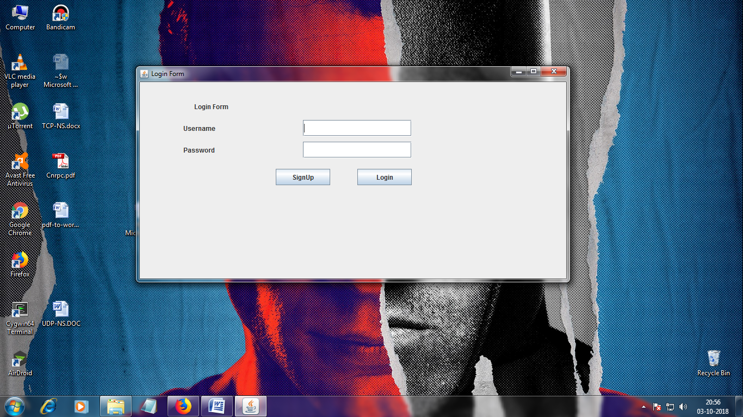

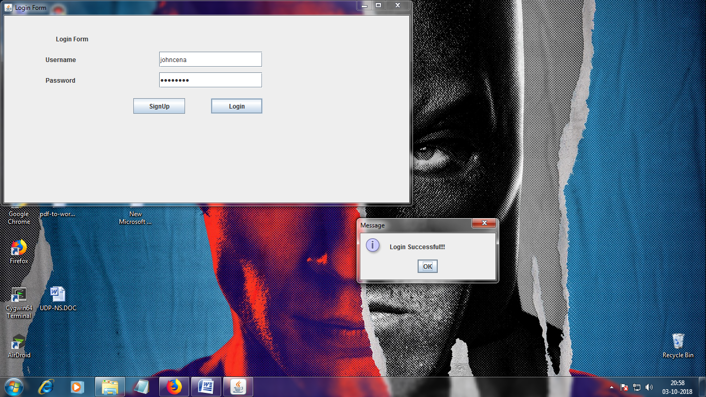

**Signup.java:**

|  |
| --- |
| package tour; |
|  |

|  |
| --- |
|  |
|  |

|  |
| --- |
| import java.awt.event.ActionEvent; |
|  |

|  |
| --- |
| import java.awt.event.ActionListener; |
|  |

|  |
| --- |
|  |
|  |

|  |
| --- |
| import javax.swing.JButton; |
|  |

|  |
| --- |
| import javax.swing.JFrame; |
|  |

|  |
| --- |
| import javax.swing.JLabel; |
|  |

|  |
| --- |
| import javax.swing.JOptionPane; |
|  |

|  |
| --- |
| import javax.swing.JPasswordField; |
|  |

|  |
| --- |
| import javax.swing.JTextField; |
|  |

|  |
| --- |
|  |
|  |

|  |
| --- |
| import com.codoid.products.exception.FilloException; |
|  |

|  |
| --- |
| import com.codoid.products.fillo.Connection; |
|  |

|  |
| --- |
| import com.codoid.products.fillo.Fillo; |
|  |

|  |
| --- |
|  |
|  |

|  |
| --- |
|  |
|  |

|  |
| --- |
| public class signup { |
|  |

|  |
| --- |
| signup(){ |
|  |

|  |
| --- |
| JFrame frame = new JFrame("SignUp Form"); |
|  |

|  |
| --- |
|  |
|  |

|  |
| --- |
|  |
|  |

|  |
| --- |
| JLabel l2 = new JLabel("Username"); |
|  |

|  |
| --- |
| JLabel l3 = new JLabel("Password"); |
|  |

|  |
| --- |
| JLabel l4 = new JLabel("Confirm Password"); |
|  |

|  |
| --- |
|  |
|  |

|  |
| --- |
| JTextField tf1 = new JTextField(); |
|  |

|  |
| --- |
| JPasswordField p1 = new JPasswordField(); |
|  |

|  |
| --- |
| JPasswordField p2 = new JPasswordField(); |
|  |

|  |
| --- |
| JButton sign =new JButton("SignUp"); |
|  |

|  |
| --- |
| l2.setBounds(80, 70, 200, 30); |
|  |

|  |
| --- |
| l3.setBounds(80, 110, 200, 30); |
|  |

|  |
| --- |
| l4.setBounds(80,150,200,30); |
|  |

|  |
| --- |
| tf1.setBounds(300, 70, 200, 30); |
|  |

|  |
| --- |
| p1.setBounds(300, 110, 200, 30); |
|  |

|  |
| --- |
| p2.setBounds(300,150,200,30); |
|  |

|  |
| --- |
| sign.setBounds(450, 200, 100, 30); |
|  |

|  |
| --- |
|  |
|  |

|  |
| --- |
|  |
|  |

|  |
| --- |
| frame.add(p2); |
|  |

|  |
| --- |
| frame.add(l2); |
|  |

|  |
| --- |
| frame.add(tf1); |
|  |

|  |
| --- |
| frame.add(l3); |
|  |

|  |
| --- |
| frame.add(p1); |
|  |

|  |
| --- |
| frame.add(l4); |
|  |

|  |
| --- |
| frame.add(sign); |
|  |

|  |
| --- |
|  |
|  |

|  |
| --- |
| frame.setSize(800, 400); |
|  |

|  |
| --- |
| frame.setLayout(null); |
|  |

|  |
| --- |
| frame.setVisible(true); |
|  |

|  |
| --- |
|  |
|  |

|  |
| --- |
|  |
|  |

|  |
| --- |
| sign.addActionListener(new ActionListener(){ |
|  |

|  |
| --- |
| public void actionPerformed(ActionEvent e){ |
|  |

|  |
| --- |
| if(p1.getText().equals(p2.getText())) { |
|  |

|  |
| --- |
| Fillo filloc= new Fillo(); |
|  |

|  |
| --- |
| Connection connection1; |
|  |

|  |
| --- |
| try { |
|  |

|  |
| --- |
| connection1 = filloc.getConnection("tour.xlsx"); |
|  |

|  |
| --- |
| String str1Queryc ="INSERT INTO Sheet1(Username,Password)VALUES('"+tf1.getText()+"','"+p1.getText()+"')"; |
|  |

|  |
| --- |
| connection1.executeUpdate(str1Queryc); |
|  |

|  |
| --- |
| connection1.close(); |
|  |

|  |
| --- |
| } catch (FilloException e1) { |
|  |

|  |
| --- |
|  |
|  |

|  |
| --- |
| e1.printStackTrace(); |
|  |

|  |
| --- |
| } |
|  |

|  |
| --- |
| JOptionPane.showMessageDialog(null,"Account created successfully"); |
|  |

|  |
| --- |
| frame.dispose(); |
|  |

|  |
| --- |
| new Loginsign(); |
|  |

|  |
| --- |
| } |
|  |

|  |
| --- |
| else { |
|  |

|  |
| --- |
|  |
|  |

|  |
| --- |
| JOptionPane.showMessageDialog(null,"Password does'nt match"); |
|  |

|  |
| --- |
| } |
|  |

|  |
| --- |
| } |
|  |

|  |
| --- |
| }); |
|  |

|  |
| --- |
|  |
|  |

|  |
| --- |
| } |
|  |

|  |
| --- |
|  |
|  |

}

**Output:**

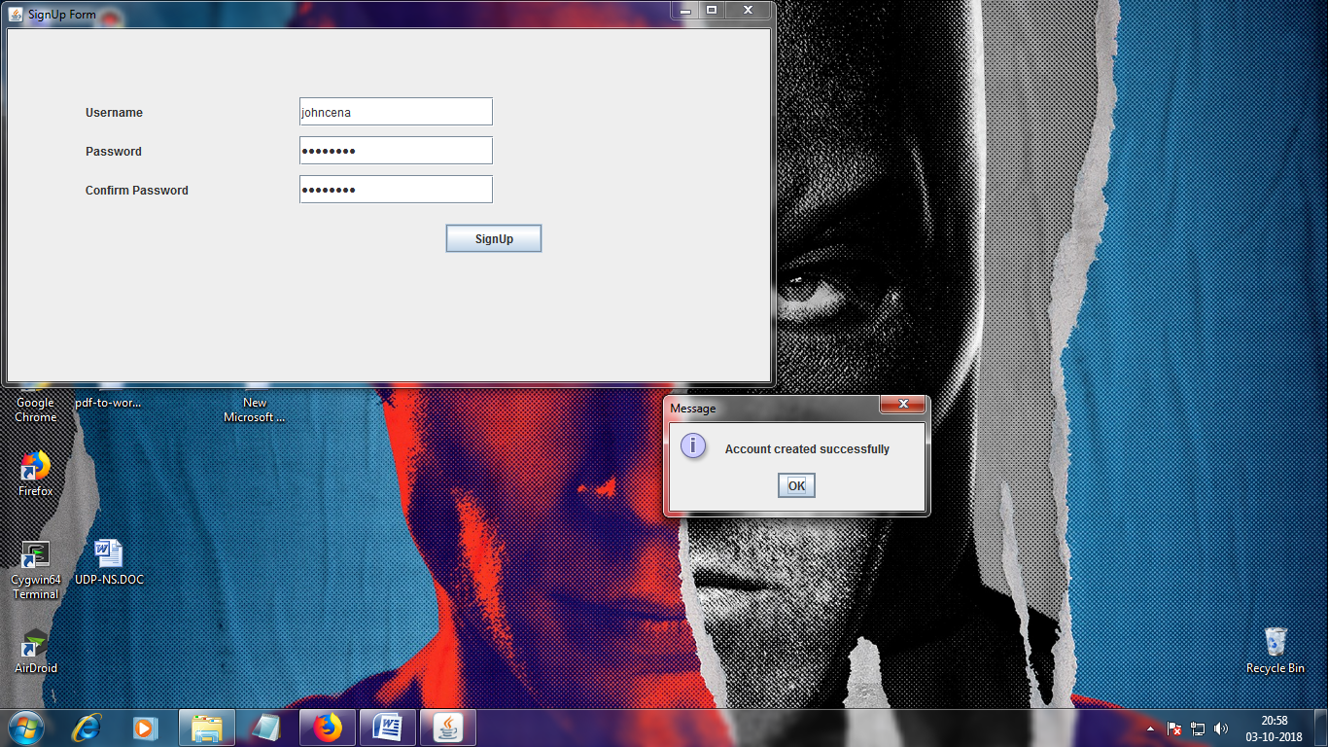

**City.java:**

|  |
| --- |
| package tour; |
|  |

|  |
| --- |
|  |
|  |

|  |
| --- |
| import java.awt.event.ActionEvent; |
|  |

|  |
| --- |
| import java.awt.event.ActionListener; |
|  |

|  |
| --- |
| import javax.swing.*; |
|  |

|  |
| --- |
|  |
|  |

|  |
| --- |
|  |
|  |

|  |
| --- |
| public class city { |
|  |

|  |
| --- |
| public static String s; |
|  |

|  |
| --- |
| city(){ |
|  |

|  |
| --- |
| String[] city = new String[] {"--select--" ,"Goa", "Cochin","Delhi", "Kashmir"}; |
|  |

|  |
| --- |
| JFrame frame = new JFrame("City"); |
|  |

|  |
| --- |
| JLabel l1 = new JLabel("Select city"); |
|  |

|  |
| --- |
| JComboBox<String> citylist = new JComboBox<>(city); |
|  |

|  |
| --- |
| JButton sign =new JButton("Select"); |
|  |

|  |
| --- |
|  |
|  |

|  |
| --- |
| l1.setBounds(40, 70, 200, 30); |
|  |

|  |
| --- |
| citylist.setBounds(130, 70, 150, 30); |
|  |

|  |
| --- |
| sign.setBounds(90, 150, 100, 30); |
|  |

|  |
| --- |
|  |
|  |

|  |
| --- |
| frame.add(l1); |
|  |

|  |
| --- |
| frame.add(citylist); |
|  |

|  |
| --- |
| frame.add(sign); |
|  |

|  |
| --- |
|  |
|  |

|  |
| --- |
| frame.setSize(350, 350); |
|  |

|  |
| --- |
| frame.setLayout(null); |
|  |

|  |
| --- |
| frame.setVisible(true); |
|  |

|  |
| --- |
|  |
|  |

|  |
| --- |
| ActionListener al = new ActionListener() { |
|  |

|  |
| --- |
|  |
|  |

|  |
| --- |
| @Override |
|  |

|  |
| --- |
| public void actionPerformed(ActionEvent e) { |
|  |

|  |
| --- |
|  |
|  |

|  |
| --- |
| s = (String) citylist.getSelectedItem() ; |
|  |

|  |
| --- |
|  |
|  |

|  |
| --- |
| switch (s) {//check for a match |
|  |

|  |
| --- |
| case "Goa": |
|  |

|  |
| --- |
| new goa(); |
|  |

|  |
| --- |
| frame.dispose(); |
|  |

|  |
| --- |
| break; |
|  |

|  |
| --- |
| case "Cochin": |
|  |

|  |
| --- |
| new cochin(); |
|  |

|  |
| --- |
| frame.dispose(); |
|  |

|  |
| --- |
| break; |
|  |

|  |
| --- |
| case "Delhi": |
|  |

|  |
| --- |
| new delhi(); |
|  |

|  |
| --- |
| frame.dispose(); |
|  |

|  |
| --- |
| break; |
|  |

|  |
| --- |
| case "Kashmir": |
|  |

|  |
| --- |
| new kashmir(); |
|  |

|  |
| --- |
| frame.dispose(); |
|  |

|  |
| --- |
| break; |
|  |

|  |
| --- |
| case "--select--": |
|  |

|  |
| --- |
| JOptionPane.showMessageDialog(null,"Select an option"); |
|  |

|  |
| --- |
| break; |
|  |

|  |
| --- |
| } |
|  |

|  |
| --- |
| } |
|  |

|  |
| --- |
| }; |
|  |

|  |
| --- |
|  |
|  |

|  |
| --- |
|  |
|  |

|  |
| --- |
| sign.addActionListener(al); |
|  |

|  |
| --- |
| } |
|  |

|  |
| --- |
|  |
|  |

}

**Output:**

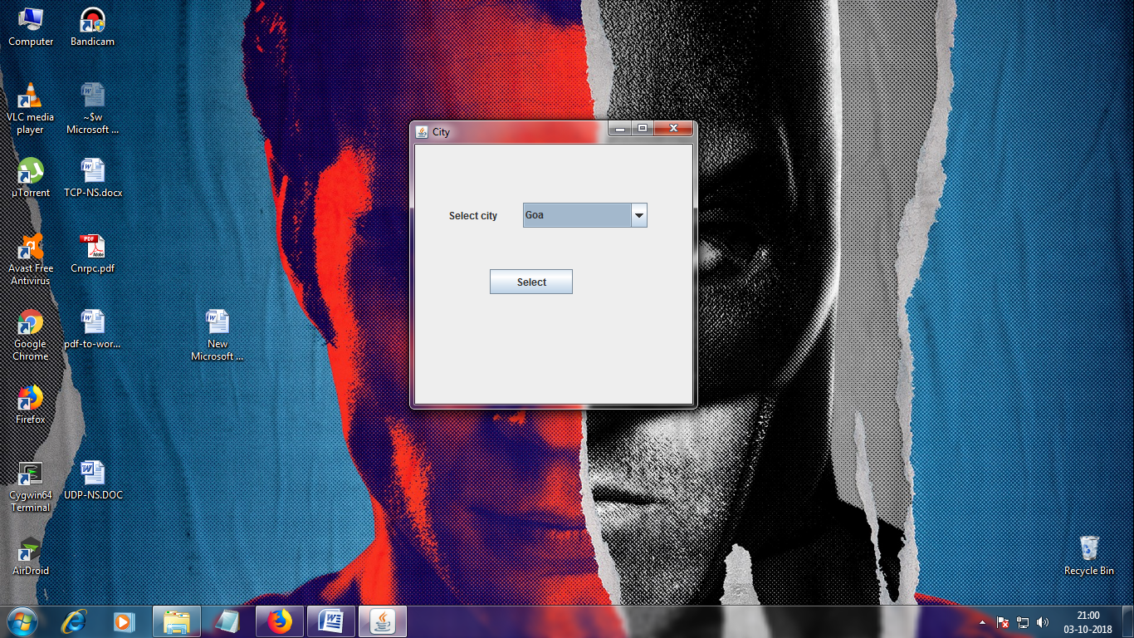

**Delhi.java:**

|  |
| --- |
| package tour; |
|  |

|  |
| --- |
|  |
|  |

|  |
| --- |
| public class delhi { |
|  |

|  |
| --- |
| static int delhi_price = 13000 ; |
|  |

|  |
| --- |
| delhi(){ |
|  |

|  |
| --- |
| person obj = new person(); |
|  |

|  |
| --- |
| obj.perso(); |
|  |

|  |
| --- |
|  |
|  |

|  |
| --- |
| } |
|  |

}

**Goa.java:**

|  |
| --- |
| package tour; |
|  |

|  |
| --- |
|  |
|  |

|  |
| --- |
|  |
|  |

|  |
| --- |
| public class goa { |
|  |

|  |
| --- |
| static int goa_price = 9000 ; |
|  |

|  |
| --- |
| goa(){ |
|  |

|  |
| --- |
| person obj = new person(); |
|  |

|  |
| --- |
| obj.perso(); |
|  |

|  |
| --- |
|  |
|  |

|  |  |
| --- | --- |
| } | |
|  |

}

**Kashmir.java:**

|  |
| --- |
| package tour; |
|  |

|  |
| --- |
|  |
|  |

|  |
| --- |
| public class kashmir { |
|  |

|  |
| --- |
| static int kashmir_price = 9000 ; |
|  |

|  |
| --- |
| kashmir(){ |
|  |

|  |
| --- |
| person obj = new person(); |
|  |

|  |
| --- |
| obj.perso(); |
|  |

|  |
| --- |
|  |
|  |

|  |
| --- |
| } |
|  |

}

**Cochin.java:**

|  |
| --- |
| package tour; |
|  |

|  |
| --- |
|  |
|  |

|  |
| --- |
| public class cochin { |
|  |

|  |
| --- |
| static int cochin_price = 8500 ; |
|  |

|  |
| --- |
| cochin(){ |
|  |

|  |
| --- |
| person obj = new person(); |
|  |

|  |
| --- |
| obj.perso(); |
|  |

|  |
| --- |
|  |
|  |

|  |
| --- |
| } |
| }  **Person.java:**   |  | | --- | | package tour; | |  |  |  | | --- | |  | |  |  |  | | --- | | import java.awt.event.ActionEvent; | |  |  |  | | --- | | import java.awt.event.ActionListener; | |  |  |  | | --- | |  | |  |  |  | | --- | | import javax.swing.JButton; | |  |  |  | | --- | | import javax.swing.JFrame; | |  |  |  | | --- | | import javax.swing.JLabel; | |  |  |  | | --- | | import javax.swing.JTextField; | |  |  |  | | --- | |  | |  |  |  | | --- | | import com.codoid.products.exception.FilloException; | |  |  |  | | --- | | import com.codoid.products.fillo.Connection; | |  |  |  | | --- | | import com.codoid.products.fillo.Fillo; | |  |  |  | | --- | |  | |  |  |  | | --- | | public class person { | |  |  |  | | --- | | public static int val, total; | |  |  |  | | --- | | int y ; | |  |  |  | | --- | | void perso(){ | |  |  |  | | --- | | JFrame frame = new JFrame("Total Persons"); | |  |  |  | | --- | |  | |  |  |  | | --- | | JLabel l1 = new JLabel("Enter No. of Persons"); | |  |  |  | | --- | | JTextField t1 = new JTextField(); | |  |  |  | | --- | | JButton sign =new JButton("Ok"); | |  |  |  | | --- | |  | |  |  |  | | --- | | l1.setBounds(40, 70, 200, 30); | |  |  |  | | --- | | t1.setBounds(200, 70, 150, 30); | |  |  |  | | --- | | sign.setBounds(90, 150, 100, 30); | |  |  |  | | --- | |  | |  |  |  | | --- | | frame.add(l1); | |  |  |  | | --- | | frame.add(t1); | |  |  |  | | --- | | frame.add(sign); | |  |  |  | | --- | |  | |  |  |  | | --- | | frame.setSize(400, 350); | |  |  |  | | --- | | frame.setLayout(null); | |  |  |  | | --- | | frame.setVisible(true); | |  |  |  | | --- | |  | |  |  |  | | --- | |  | |  |  |  | | --- | | ActionListener al = new ActionListener() { | |  |  |  | | --- | | @Override | |  |  |  | | --- | | public void actionPerformed(ActionEvent e) { | |  |  |  | | --- | | String i = t1.getText(); | |  |  |  | | --- | | val = Integer.parseInt(i); | |  |  |  | | --- | | frame.dispose(); | |  |  |  | | --- | | y = tour.person.val ; | |  |  |  | | --- | | for (int x = tour.person.val; x > 0; x--) | |  |  |  | | --- | | { | |  |  |  | | --- | | person_swing(x); | |  |  |  | | --- | | } | |  |  |  | | --- | |  | |  |  |  | | --- | | } | |  |  |  | | --- | | }; | |  |  |  | | --- | | sign.addActionListener(al); | |  |  |  | | --- | |  | |  |  |  | | --- | |  | |  |  |  | | --- | | } | |  |  |  | | --- | | void person_swing(int x) { | |  |  |  | | --- | |  | |  |  |  | | --- | | JFrame frame = new JFrame("Details"); | |  |  |  | | --- | | JLabel l1 = new JLabel("Person "+(x)); | |  |  |  | | --- | | JLabel l2 = new JLabel("Name"); | |  |  |  | | --- | | JLabel l3 = new JLabel("Age"); | |  |  |  | | --- | | JLabel l4 = new JLabel("Gender"); | |  |  |  | | --- | | JTextField t1 = new JTextField(); | |  |  |  | | --- | | JTextField t2 = new JTextField(); | |  |  |  | | --- | | JTextField t3 = new JTextField(); | |  |  |  | | --- | | JButton ok =new JButton("ok"); | |  |  |  | | --- | |  | |  |  |  | | --- | |  | |  |  |  | | --- | | l1.setBounds(100, 30, 400, 30); | |  |  |  | | --- | | l2.setBounds(80, 70, 200, 30); | |  |  |  | | --- | | l3.setBounds(80, 110, 200, 30); | |  |  |  | | --- | | l4.setBounds(80,150,200,30); | |  |  |  | | --- | | t1.setBounds(300, 70, 200, 30); | |  |  |  | | --- | | t2.setBounds(300, 110, 200, 30); | |  |  |  | | --- | | t3.setBounds(300,150,200,30); | |  |  |  | | --- | | ok.setBounds(450, 200, 100, 30); | |  |  |  | | --- | |  | |  |  |  | | --- | | frame.add(l1); | |  |  |  | | --- | | frame.add(l2); | |  |  |  | | --- | | frame.add(l3); | |  |  |  | | --- | | frame.add(l4); | |  |  |  | | --- | | frame.add(t1); | |  |  |  | | --- | | frame.add(t2); | |  |  |  | | --- | | frame.add(t3); | |  |  |  | | --- | | frame.add(ok); | |  |  |  | | --- | |  | |  |  |  | | --- | | frame.setSize(800, 400); | |  |  |  | | --- | | frame.setLayout(null); | |  |  |  | | --- | | frame.setVisible(true); | |  |  |  | | --- | |  | |  |  |  | | --- | |  | |  |  |  | | --- | |  | |  |  |  | | --- | | cost_display obj3 = new cost_display(); | |  |  |  | | --- | |  | |  |  |  | | --- | | if(city.s == "Goa") | |  |  |  | | --- | | { | |  |  |  | | --- | | ok.addActionListener(new ActionListener(){ | |  |  |  | | --- | | public void actionPerformed(ActionEvent e){ | |  |  |  | | --- | | Fillo filloc= new Fillo(); | |  |  |  | | --- | | Connection connection1; | |  |  |  | | --- | | try { | |  |  |  | | --- | | connection1 = filloc.getConnection("tour.xlsx"); | |  |  |  | | --- | | String str1Queryc ="INSERT INTO Sheet2(Name,Age,Gender)VALUES('"+t1.getText()+"','"+t2.getText()+"','"+t3.getText()+"')"; | |  |  |  | | --- | | connection1.executeUpdate(str1Queryc); | |  |  |  | | --- | | connection1.close(); | |  |  |  | | --- | |  | |  |  |  | | --- | |  | |  |  |  | | --- | | y = y - 1; | |  |  |  | | --- | | } catch (FilloException e1) { | |  |  |  | | --- | |  | |  |  |  | | --- | | e1.printStackTrace(); | |  |  |  | | --- | | } | |  |  |  | | --- | | frame.dispose(); | |  |  |  | | --- | | total = val * goa.goa_price ; | |  |  |  | | --- | | if(y==0) | |  |  |  | | --- | | { | |  |  |  | | --- | | obj3.costDisplay(); | |  |  |  | | --- | | } | |  |  |  | | --- | | } | |  |  |  | | --- | | }); | |  |  |  | | --- | |  | |  |  |  | | --- | | } | |  |  |  | | --- | |  | |  |  |  | | --- | | else if(city.s=="Cochin") | |  |  |  | | --- | | { | |  |  |  | | --- | | ok.addActionListener(new ActionListener(){ | |  |  |  | | --- | | public void actionPerformed(ActionEvent e){ | |  |  |  | | --- | | Fillo filloc= new Fillo(); | |  |  |  | | --- | | Connection connection1; | |  |  |  | | --- | | try { | |  |  |  | | --- | | connection1 = filloc.getConnection("tour.xlsx"); | |  |  |  | | --- | | String str1Queryc ="INSERT INTO Sheet3(Name,Age,Gender)VALUES('"+t1.getText()+"','"+t2.getText()+"','"+t3.getText()+"')"; | |  |  |  | | --- | | connection1.executeUpdate(str1Queryc); | |  |  |  | | --- | | connection1.close(); | |  |  |  | | --- | | y = y - 1; | |  |  |  | | --- | | } catch (FilloException e1) { | |  |  |  | | --- | |  | |  |  |  | | --- | | e1.printStackTrace(); | |  |  |  | | --- | | } | |  |  |  | | --- | | frame.dispose(); | |  |  |  | | --- | | total = val * cochin.cochin_price; | |  |  |  | | --- | | if(y==0) | |  |  |  | | --- | | { | |  |  |  | | --- | | obj3.costDisplay(); | |  |  |  | | --- | | } | |  |  |  | | --- | | } | |  |  |  | | --- | | }); | |  |  |  | | --- | | } | |  |  |  | | --- | |  | |  |  |  | | --- | | else if(city.s=="Delhi") | |  |  |  | | --- | | { | |  |  |  | | --- | | ok.addActionListener(new ActionListener(){ | |  |  |  | | --- | | public void actionPerformed(ActionEvent e){ | |  |  |  | | --- | | Fillo filloc= new Fillo(); | |  |  |  | | --- | | Connection connection1; | |  |  |  | | --- | | try { | |  |  |  | | --- | | connection1 = filloc.getConnection("tour.xlsx"); | |  |  |  | | --- | | String str1Queryc ="INSERT INTO Sheet4(Name,Age,Gender)VALUES('"+t1.getText()+"','"+t2.getText()+"','"+t3.getText()+"')"; | |  |  |  | | --- | | connection1.executeUpdate(str1Queryc); | |  |  |  | | --- | | connection1.close(); | |  |  |  | | --- | | y = y - 1; | |  |  |  | | --- | | } catch (FilloException e1) { | |  |  |  | | --- | |  | |  |  |  | | --- | | e1.printStackTrace(); | |  |  |  | | --- | | } | |  |  |  | | --- | | frame.dispose(); | |  |  |  | | --- | | total = val * delhi.delhi_price; | |  |  |  | | --- | | if(y==0) | |  |  |  | | --- | | { | |  |  |  | | --- | | obj3.costDisplay(); | |  |  |  | | --- | | } | |  |  |  | | --- | | } | |  |  |  | | --- | | }); | |  |  |  | | --- | | } | |  |  |  | | --- | |  | |  |  |  | | --- | | else if(city.s == "Kashmir") | |  |  |  | | --- | | { | |  |  |  | | --- | | ok.addActionListener(new ActionListener(){ | |  |  |  | | --- | | public void actionPerformed(ActionEvent e){ | |  |  |  | | --- | | Fillo filloc= new Fillo(); | |  |  |  | | --- | | Connection connection1; | |  |  |  | | --- | | try { | |  |  |  | | --- | | connection1 = filloc.getConnection("tour.xlsx"); | |  |  |  | | --- | | String str1Queryc ="INSERT INTO Sheet5(Name,Age,Gender)VALUES('"+t1.getText()+"','"+t2.getText()+"','"+t3.getText()+"')"; | |  |  |  | | --- | | connection1.executeUpdate(str1Queryc); | |  |  |  | | --- | | connection1.close(); | |  |  |  | | --- | | } catch (FilloException e1) { | |  |  |  | | --- | |  | |  |  |  | | --- | | e1.printStackTrace(); | |  |  |  | | --- | | } | |  |  |  | | --- | | frame.dispose(); | |  |  |  | | --- | | total = val * kashmir.kashmir_price; | |  |  |  | | --- | | if(y==0) | |  |  |  | | --- | | { | |  |  |  | | --- | | obj3.costDisplay(); | |  |  |  | | --- | | } | |  |  |  | | --- | | } | |  |  |  | | --- | | }); | |  |  |  | | --- | | } | |  |  |  | | --- | |  | |  |  |  | | --- | | } | |  |  |  | | --- | |  | |  |   }  **Output:**    **C:\Users\Dilipan\Desktop\Untitled.png**    **Cost_display.java:**   |  | | --- | | package tour; | |  |  |  | | --- | |  | |  |  |  | | --- | | import javax.swing.JButton; | |  |  |  | | --- | | import javax.swing.JFrame; | |  |  |  | | --- | | import javax.swing.JLabel; | |  |  |  | | --- | | import java.awt.event.ActionEvent; | |  |  |  | | --- | | import java.awt.event.ActionListener; | |  |  |  | | --- | |  | |  |  |  | | --- | | public class cost_display { | |  |  |  | | --- | | void costDisplay(){ | |  |  |  | | --- | | JFrame frame = new JFrame("Confirmation"); | |  |  |  | | --- | |  | |  |  |  | | --- | | JLabel l1 = new JLabel("No. of Persons : " + person.val ); | |  |  |  | | --- | | JLabel l2 = new JLabel("Total Cost : " + person.total); | |  |  |  | | --- | | JButton ok2 =new JButton("Confirm"); | |  |  |  | | --- | |  | |  |  |  | | --- | | l1.setBounds(80, 70, 200, 30); | |  |  |  | | --- | | l2.setBounds(80, 110, 200, 30); | |  |  |  | | --- | | ok2.setBounds(450, 200, 100, 30); | |  |  |  | | --- | |  | |  |  |  | | --- | | frame.add(l1); | |  |  |  | | --- | | frame.add(l2); | |  |  |  | | --- | | frame.add(ok2); | |  |  |  | | --- | |  | |  |  |  | | --- | | frame.setSize(800, 400); | |  |  |  | | --- | | frame.setLayout(null); | |  |  |  | | --- | | frame.setVisible(true); | |  |  |  | | --- | |  | |  |  |  | | --- | |  | |  |  |  | | --- | | ok2.addActionListener(new ActionListener(){ | |  |  |  | | --- | | public void actionPerformed(ActionEvent e){ | |  |  |  | | --- | | new bank(); | |  |  |  | | --- | | frame.dispose(); | |  |  |  | | --- | | } | |  |  |  | | --- | | }); | |  |  |  | | --- | |  | |  |  |  | | --- | |  | |  |  |  | | --- | | } | |  |   }  **Output:**    **Bank.java:**   |  | | --- | | package tour; | |  |  |  | | --- | |  | |  |  |  | | --- | | import javax.swing.JButton; | |  |  |  | | --- | | import javax.swing.JFrame; | |  |  |  | | --- | | import javax.swing.JLabel; | |  |  |  | | --- | | import javax.swing.JTextField; | |  |  |  | | --- | | import javax.swing.JPasswordField; | |  |  |  | | --- | | import javax.swing.JOptionPane; | |  |  |  | | --- | | import com.codoid.products.exception.FilloException; | |  |  |  | | --- | | import com.codoid.products.fillo.Connection; | |  |  |  | | --- | | import com.codoid.products.fillo.Fillo; | |  |  |  | | --- | | import com.codoid.products.fillo.Recordset; | |  |  |  | | --- | | import java.awt.event.ActionEvent; | |  |  |  | | --- | | import java.awt.event.ActionListener; | |  |  |  | | --- | |  | |  |  |  | | --- | | public class bank { | |  |  |  | | --- | | bank(){ | |  |  |  | | --- | | JFrame frame = new JFrame("Bank Login"); | |  |  |  | | --- | |  | |  |  |  | | --- | | JLabel l1 = new JLabel("Internet-Banking"); | |  |  |  | | --- | | JLabel l2 = new JLabel("BankId"); | |  |  |  | | --- | | JLabel l3 = new JLabel("Password"); | |  |  |  | | --- | | JTextField tf1 = new JTextField(); | |  |  |  | | --- | | JPasswordField p1 = new JPasswordField(); | |  |  |  | | --- | | JButton btn1 = new JButton("Login"); | |  |  |  | | --- | |  | |  |  |  | | --- | | l1.setBounds(100, 30, 400, 30); | |  |  |  | | --- | | l2.setBounds(80, 70, 200, 30); | |  |  |  | | --- | | l3.setBounds(80, 110, 200, 30); | |  |  |  | | --- | | tf1.setBounds(300, 70, 200, 30); | |  |  |  | | --- | | p1.setBounds(300, 110, 200, 30); | |  |  |  | | --- | | btn1.setBounds(400, 160, 100, 30); | |  |  |  | | --- | |  | |  |  |  | | --- | | frame.add(l1); | |  |  |  | | --- | | frame.add(l2); | |  |  |  | | --- | | frame.add(tf1); | |  |  |  | | --- | | frame.add(l3); | |  |  |  | | --- | | frame.add(p1); | |  |  |  | | --- | | frame.add(btn1); | |  |  |  | | --- | |  | |  |  |  | | --- | | frame.setSize(800, 400); | |  |  |  | | --- | | frame.setLayout(null); | |  |  |  | | --- | | frame.setVisible(true); | |  |  |  | | --- | |  | |  |  |  | | --- | | btn1.addActionListener(new ActionListener(){ | |  |  |  | | --- | | public void actionPerformed(ActionEvent e){ | |  |  |  | | --- | | String un=tf1.getText(); | |  |  |  | | --- | | String pwd=p1.getText(); | |  |  |  | | --- | | int stats=0; | |  |  |  | | --- | | Fillo filloc= new Fillo(); | |  |  |  | | --- | | Connection connection1; | |  |  |  | | --- | | try { | |  |  |  | | --- | | connection1 = filloc.getConnection("tour.xlsx"); | |  |  |  | | --- | | String str1Queryc ="SELECT * FROM Sheet6 WHERE EXISTS (SELECT BankId FROM Sheet1 WHERE BankId='"+btn1.getText()+"')"; | |  |  |  | | --- | |  | |  |  |  | | --- | |  | |  |  |  | | --- | | Recordset rsc=connection1.executeQuery(str1Queryc); | |  |  |  | | --- | | if(un.equals("") ||pwd.equals("")) { | |  |  |  | | --- | |  | |  |  |  | | --- | | JOptionPane.showMessageDialog(null,"Kindly Enter both your BankId and Password"); | |  |  |  | | --- | | }else { | |  |  |  | | --- | | while(rsc.next()) { | |  |  |  | | --- | | if(rsc.getField("Password").equals(pwd)) { | |  |  |  | | --- | | JOptionPane.showMessageDialog(null,"Login Successful!!!"); | |  |  |  | | --- | | new Transaction(tour.person.total,un,"Sheet6"); | |  |  |  | | --- | | frame.dispose(); | |  |  |  | | --- | | stats=stats+1; | |  |  |  | | --- | | break; | |  |  |  | | --- | | } | |  |  |  | | --- | |  | |  |  |  | | --- | | } | |  |  |  | | --- | | if(stats==0){ | |  |  |  | | --- | | JOptionPane.showMessageDialog(null,"Incorrect BankId or Password"); | |  |  |  | | --- | |  | |  |  |  | | --- | | } | |  |  |  | | --- | | } | |  |  |  | | --- | |  | |  |  |  | | --- | | } catch (FilloException e1) { | |  |  |  | | --- | |  | |  |  |  | | --- | | } | |  |  |  | | --- | |  | |  |  |  | | --- | |  | |  |  |  | | --- | | } | |  |  |  | | --- | | }); | |  |  |  | | --- | | } | |  |  |  | | --- | |  | |  |   }  **Output:**    **Transaction.java:**   |  | | --- | | package tour; | |  |  |  | | --- | |  | |  |  |  | | --- | | import java.awt.event.ActionEvent; | |  |  |  | | --- | | import java.awt.event.ActionListener; | |  |  |  | | --- | |  | |  |  |  | | --- | | import javax.swing.JButton; | |  |  |  | | --- | | import javax.swing.JFrame; | |  |  |  | | --- | | import javax.swing.JLabel; | |  |  |  | | --- | | import javax.swing.JOptionPane; | |  |  |  | | --- | | import javax.swing.JPasswordField; | |  |  |  | | --- | | import javax.swing.JTextField; | |  |  |  | | --- | |  | |  |  |  | | --- | | import com.codoid.products.exception.FilloException; | |  |  |  | | --- | | import com.codoid.products.fillo.Connection; | |  |  |  | | --- | | import com.codoid.products.fillo.Fillo; | |  |  |  | | --- | | import com.codoid.products.fillo.Recordset; | |  |  |  | | --- | |  | |  |  |  | | --- | | public class Transaction { | |  |  |  | | --- | | Transaction(int amt,String un,String s1){ | |  |  |  | | --- | | JFrame tr=new JFrame("Transaction"); | |  |  |  | | --- | | JLabel no = new JLabel("Total Number of seats:"+tour.person.val+""); | |  |  |  | | --- | | JLabel cost = new JLabel("Total Cost:"+amt+""); | |  |  |  | | --- | | JLabel l3 = new JLabel("Transaction Password:"); | |  |  |  | | --- | |  | |  |  |  | | --- | | JPasswordField tf1 = new JPasswordField(); | |  |  |  | | --- | | JButton btn=new JButton("Confirm"); | |  |  |  | | --- | |  | |  |  |  | | --- | | no.setBounds(100, 30, 400, 30); | |  |  |  | | --- | | cost.setBounds(100, 70, 200, 30); | |  |  |  | | --- | | l3.setBounds(100, 110, 200, 30); | |  |  |  | | --- | | tf1.setBounds(300, 110, 200, 30); | |  |  |  | | --- | | btn.setBounds(400, 160, 100, 30); | |  |  |  | | --- | |  | |  |  |  | | --- | | tr.add(no); | |  |  |  | | --- | | tr.add(cost); | |  |  |  | | --- | | tr.add(l3); | |  |  |  | | --- | | tr.add(tf1); | |  |  |  | | --- | | tr.add(btn); | |  |  |  | | --- | |  | |  |  |  | | --- | | tr.setSize(800, 400); | |  |  |  | | --- | | tr.setLayout(null); | |  |  |  | | --- | | tr.setVisible(true); | |  |  |  | | --- | | btn.addActionListener(new ActionListener(){ | |  |  |  | | --- | | public void actionPerformed(ActionEvent e){ | |  |  |  | | --- | | String un1=tf1.getText(); | |  |  |  | | --- | | int stats=0; | |  |  |  | | --- | | Fillo filloc= new Fillo(); | |  |  |  | | --- | | Connection connection1; | |  |  |  | | --- | | try { | |  |  |  | | --- | | connection1 = filloc.getConnection("tour.xlsx"); | |  |  |  | | --- | | String str1Queryc ="SELECT * FROM Sheet6 WHERE EXISTS (SELECT BankId FROM Sheet1 WHERE TransactionId='"+tf1.getText()+"' and BankId='"+un+"')"; | |  |  |  | | --- | |  | |  |  |  | | --- | |  | |  |  |  | | --- | | Recordset rsc=connection1.executeQuery(str1Queryc); | |  |  |  | | --- | | if(un1.equals("")) { | |  |  |  | | --- | |  | |  |  |  | | --- | | JOptionPane.showMessageDialog(null,"Kindly Enter both your TransactionId "); | |  |  |  | | --- | | }else { | |  |  |  | | --- | | while(rsc.next()) { | |  |  |  | | --- | | if(rsc.getField("TransactionId").equals(un1)&&(Integer.parseInt(rsc.getField("Balance"))>amt)) { | |  |  |  | | --- | | int amt1=Integer.parseInt(rsc.getField("Balance")); | |  |  |  | | --- | | amt1=amt1-amt; | |  |  |  | | --- | | String upp= Integer.toString(amt1); | |  |  |  | | --- | | String strup="Update Sheet6 Set Balance='"+amt1+"' where BankId='"+un+"' "; | |  |  |  | | --- | | connection1.executeUpdate(strup); | |  |  |  | | --- | | JOptionPane.showMessageDialog(null,"Transaction Successful!!!"); | |  |  |  | | --- | | tr.dispose(); | |  |  |  | | --- | | new Finish(); | |  |  |  | | --- | | stats+=1; | |  |  |  | | --- | | //new Update(s1,dat1,Mov1,Tim1); | |  |  |  | | --- | | break; | |  |  |  | | --- | | } | |  |  |  | | --- | |  | |  |  |  | | --- | | } | |  |  |  | | --- | | if(stats==0){ | |  |  |  | | --- | | JOptionPane.showMessageDialog(null,"Incorrect BankId or Password"); | |  |  |  | | --- | |  | |  |  |  | | --- | | } | |  |  |  | | --- | | } | |  |  |  | | --- | |  | |  |  |  | | --- | | } catch (FilloException e1) { | |  |  |  | | --- | | e1.printStackTrace(); | |  |  |  | | --- | | } | |  |  |  | | --- | |  | |  |  |  | | --- | |  | |  |  |  | | --- | | } | |  |  |  | | --- | | }); | |  |  |  | | --- | | } | |  |   }  **Output:**    **Finish.java:**   |  | | --- | | package tour; | |  |  |  | | --- | |  | |  |  |  | | --- | | import java.awt.event.ActionEvent; | |  |  |  | | --- | | import java.awt.event.ActionListener; | |  |  |  | | --- | |  | |  |  |  | | --- | | import javax.swing.JButton; | |  |  |  | | --- | | import javax.swing.JFrame; | |  |  |  | | --- | | import javax.swing.JLabel; | |  |  |  | | --- | |  | |  |  |  | | --- | | public class Finish { | |  |  |  | | --- | | Finish(){ | |  |  |  | | --- | | JFrame frame=new JFrame("Success!"); | |  |  |  | | --- | |  | |  |  |  | | --- | | JLabel l3 = new JLabel("Your " + tour.person.val +" tickets have been succesfully booked "); | |  |  |  | | --- | | JLabel l4 = new JLabel("and the amount of Rs."+ tour.person.total); | |  |  |  | | --- | | JLabel l5 = new JLabel("has been successfully transfered from your account"); | |  |  |  | | --- | | JButton btn=new JButton("Confirm"); | |  |  |  | | --- | |  | |  |  |  | | --- | | l3.setBounds(50, 50, 500, 50); | |  |  |  | | --- | | l4.setBounds(50, 80, 500, 50); | |  |  |  | | --- | | l5.setBounds(50, 110, 500, 50); | |  |  |  | | --- | | btn.setBounds(130, 180, 80, 30); | |  |  |  | | --- | |  | |  |  |  | | --- | | frame.add(l3); | |  |  |  | | --- | | frame.add(l4); | |  |  |  | | --- | | frame.add(l5); | |  |  |  | | --- | | frame.add(btn); | |  |  |  | | --- | |  | |  |  |  | | --- | | frame.setSize(400, 350); | |  |  |  | | --- | | frame.setLayout(null); | |  |  |  | | --- | | frame.setVisible(true); | |  |  |  | | --- | |  | |  |  |  | | --- | | btn.addActionListener(new ActionListener(){ | |  |  |  | | --- | | public void actionPerformed(ActionEvent e){ | |  |  |  | | --- | | frame.dispose(); | |  |  |  | | --- | | } | |  |  |  | | --- | | }); | |  |  |  | | --- | | } | |  |   }  **Output:**    **Database output:** |